
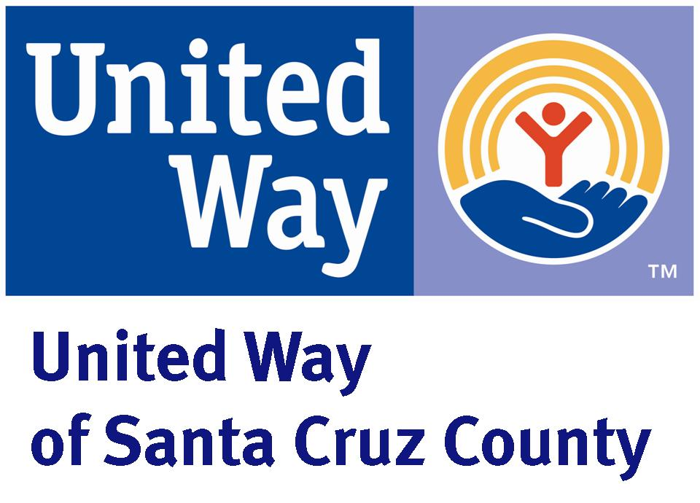
S. H. Cowell Community Conference
Room Guidelines

- Parking: If there are more than 5 people attending a meeting please park outside the parking lot unless it is after business hours.

- Scheduling: Reservations cannot be made two or more months in advance.

- Cleaning: Please leave the Conference Room and kitchen in a clean and orderly condition. After the meeting, please arrange the tables and chairs according to the diagram posted on the walls and remove your trash to the dumpster located in the parking lot behind the building. (The combo for the lock is 4450) Cleaning supplies and garbage bags are available in the black cabinet in the hall next to the side entry door. Please wipe down tables and vacuum floor if necessary.

- Cellular Phone Usage: As a courtesy to United Way and First 5 staff we ask that you please have phone conversations outside. During breaks please let your attendees know that they need to be respectful and keep in mind that this is a working office and to avoid creating interruptions for office staff.

- Damages: Organizations are financially liable for any damages to the facility or equipment, as well as any cleaning costs during the time of usage as assessed and determined by United Way and First 5 staff.

- Entrance and Exit Procedures: During business hours please remember to ENTER and EXIT through the main lobby and front door of the building. For usage after hours and on weekends, please use our side entrance only and remember to lock our front door if you need to use the restrooms in the lobby of the building. Please remind your attendees to do the same. The facilitator is responsible for making sure attendees adhere to our guidelines.

- Key Return: Please leave the key with the receptionist after use. For after hours use please deposit the key with the envelope provided through the space between the side doors after you have locked up; shut off the lights; and ensure that the front door is securely shut and locked. The facilitator is also responsible for making sure the main lobby entrance to the building is locked when room is used after regular office hours or on weekends.

- Kitchen/Breakroom Supplies: Please bring all coffee, tea, cups, utensils, etc. for your personal use. Do NOT use our paper cups, water, flip chart paper, copier, coffee machine or any other kitchen supplies. These materials are for United Way/First 5 employees only. We ask that you respect this agreement.

- Meeting Times: Organizations are responsible to ensure meetings conclude by the time indicated on the reservation form. Organizations must allow ample time to set-up before and clean-up after all meetings.

- Outside Areas: Please note that users of the conference room should not loiter on the front steps to the main lobby. If meeting attendees would like to eat or take brakes outside they may do so on the steps to our side entrance or on the grassy area adjacent to 45th Avenue.

- Restrooms: Restrooms are available for use in the main lobby. The women’s restroom requires a key for access. The women’s restroom key is located in the counter on the ledge of the reception desk. The men’s restroom does not require a key for access but a code #2468. (Office building restrooms and transgender; please do not post additional signs on the restroom doors - a person can use the restroom that identifies closely to them.)

- Room Capacity: In the event more participants attend than originally indicated and room capacity is exceeded, United Way and First 5 staff cannot guarantee a meeting space to accommodate your needs.

- Bicycles: Bicycles are not allowed inside our office. Please park them in the parking lot.

- Walls/Doors/Windows: Please do not use tape, screws, or drive nails into any doors, walls or woodwork. Removable masking/painting tape may be used.

In case of extreme or life threatening emergency, please call 911. If there is any building issue while using the room on a weekend please notify Brenda Gonzalez (831) 465-2201. For any general questions or concerns or for scheduling of the conference room, please call (831) 479-5466 during normal business hours.

